Appendix A:

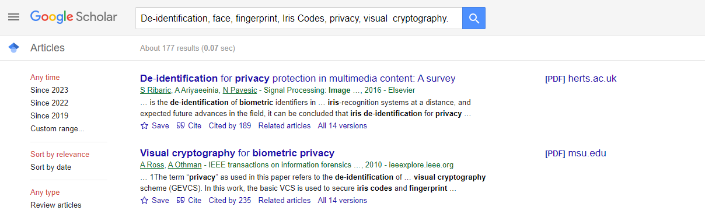

Appendix B:

